
Replacing Barbecue Gas
(Friends and Family)

Barbecue Gas
There’s usually plenty of barbecue gas – we keep two bottles – one being active and in use, the other kept full if the first runs out. If the active one runs out then feel free to swap to the backup. But we’d appreciate if you could refill the empty one to be the new backup!
- Take the empty gas bottle to this place – the Curgas outlet at the Curoil Petrol Station in nearby Tera Kora: https://maps.app.goo.gl/RiHwY7zGS7Xi7d1y9
…note the opening times on the Google maps page are incorrect!!! See image below:
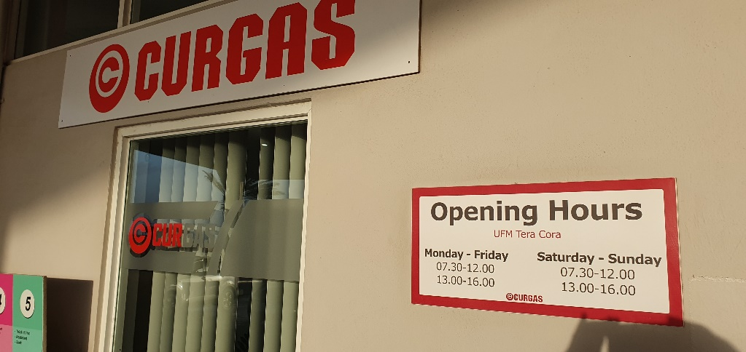
- Approach the above counter and hold up the gas bottle and say you want ‘BARBECUE GAS’. They will charge you NAF32 (or the USD equivalent) and give you a token
- Take the token over to the building indicated in red below and give the bottle to the guy inside. He will take your token, fill up the gas bottle and give it back to you. All done – thanks!!!
